**Web API(Web Application Programming Interface)**

**Introduction to Web API :**

A Web API (Web Application Programming Interface) is a set of protocols and tools that allows different software applications to communicate over the internet using standard web protocols, primarily HTTP. It enables developers to access and manipulate data or services from other software applications, facilitating integration and interoperability between diverse systems.

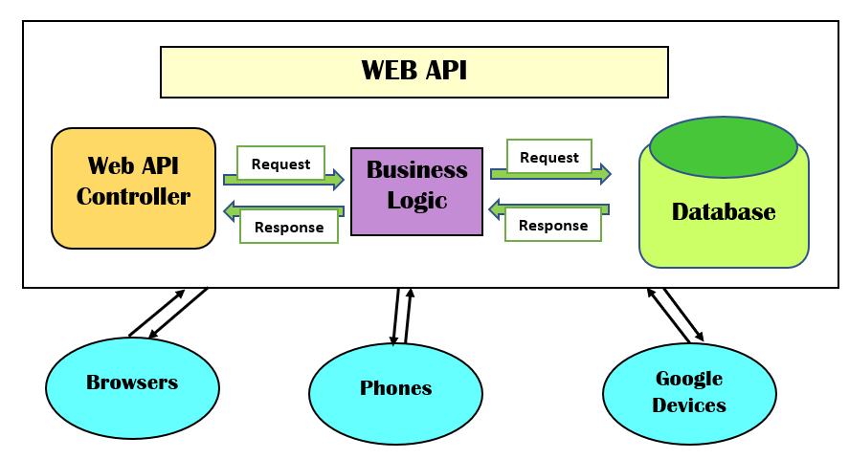

**Key Features of Web API:**

* HTTP-Based Communication: Web APIs operate over the HTTP protocol, making them accessible through standard web requests.
* Data Formats: They commonly use data formats like JSON or XML for structured data exchange.
* Endpoints: Web APIs expose specific URLs (endpoints) that correspond to different functionalities or data resources.
* Statelessness: Each request from a client to a server must contain all the information needed to understand and process the request, ensuring that no client context is stored on the server between requests.

**Common Types of Web API :**

* REST (Representational State Transfer): A widely adopted architectural style that uses standard HTTP methods (GET, POST, PUT, DELETE) for operations. RESTful APIs are known for their simplicity and scalability.
* SOAP (Simple Object Access Protocol): A protocol that uses XML for message formatting and relies on other application layer protocols, such as HTTP and SMTP, for message negotiation and transmission.
* GraphQL: A query language for APIs that allows clients to request exactly the data they need, making APIs more efficient and flexible.

**Common HTTP Verbs in Web API :**

1. GET
   * Purpose: Retrieve data from the server.
   * Characteristics: Safe and idempotent; does not modify server state.
   * Use Cases: Fetching a list of users, retrieving details of a specific product.
2. POST
   * Purpose: Create a new resource on the server.
   * Characteristics: Not idempotent; multiple identical requests may result in multiple resource creations.
   * Use Cases: Submitting a new blog post, registering a new user.
3. PUT
   * Purpose: Update an existing resource or create it if it doesn't exist.
   * Characteristics: Idempotent; multiple identical requests result in the same state.
   * Use Cases: Updating user information, replacing a document.
4. DELETE

* Purpose: Remove a resource from the server.
* Characteristics: Idempotent; deleting a non-existent resource yields the same result.
* Use Cases: Deleting a user account, removing a file.

**Key Benefits of Web API :**

1. Seamless Integration and Interoperability

Web APIs enable different software systems to communicate and share data efficiently, regardless of their underlying technologies. This facilitates integration with third-party services, such as payment gateways, social media platforms, and cloud storage services, enhancing the functionality of applications.

2. Accelerated Development and Time-to-Market

By leveraging existing APIs, developers can incorporate pre-built functionalities into their applications, reducing development time and costs. This accelerates the time-to-market for new products and features.

3. Enhanced Scalability and Flexibility

APIs allow applications to scale efficiently by handling increased loads and adapting to changing business needs. They provide the flexibility to modify or extend functionalities without overhauling the entire system.

4. Improved User Experience

Through APIs, applications can offer real-time data updates, personalized content, and seamless interactions across multiple platforms, leading to a more engaging user experience.

5. Cost Efficiency

Utilizing APIs reduces the need to develop functionalities from scratch, leading to significant cost savings in development and maintenance. Additionally, many APIs follow a pay-as-you-go model, allowing businesses to manage expenses based on usage.

6. Fostering Innovation and Collaboration

APIs encourage innovation by enabling developers to build upon existing services and create new applications. They also facilitate collaboration between different organizations, leading to the development of integrated solutions.

**Practical Applications of Web API :**

* Third-Party Integrations: Web APIs enable integration with external services, such as payment gateways, social media platforms, and cloud storage services.
* Mobile and Web Applications: They allow mobile apps and web applications to retrieve and display dynamic content from servers.
* IoT Devices: Web APIs facilitate communication between Internet of Things (IoT) devices and central servers or cloud services.